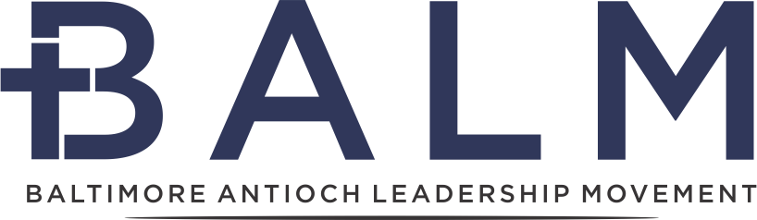

Baltimore Underground Church Network
Missionary Disciple-Making Training Pathway 2024
(Online ZOOM Cohort)

The Need

The American church faces a multitude of challenges, and we see these reflected in our cities and Baltimore metro region. Nationally, surveys reveal that approximately 80-90% of churches have plateaued or are in decline, and 93% are not reproducing. Overall, pastoral leaders are aging and fewer young emerging leaders are interested in vocational ministry. Socio-economic challenges abound in cities and metro regions; there are now more people struggling in poverty in the county than in the city. Ethnic diversity is increasing, and White people will soon become just one minority among several minorities. Political polarization continues to challenge gospel unity. The economics of supporting and staffing the prevailing model of church and her missions is being strained. These contextual challenges existed before COVID19 and have only compounded since then, exposing our vulnerabilities to robust mission.

The Ancient Model: “They broke bread in their homes and ate together with glad and sincere hearts..." (Acts 2:46) "Day after day, in the Temple courts and from house to house, they never stopped teaching and proclaiming the good news that Jesus is the Christ." (Acts 5:42)”And the Lord added to their number daily those who were being saved.(Acts 2:47)”

Greet Prisca and Aquila, my fellow workers in Christ Jesus, who risked their necks for my life… Greet also the church in their house. Romans 16:3-5

The book of Acts informs us that the basic ecclesiastical unit for worship, spiritual nurture, care, instruction and missional advance of the Kingdom was the church meeting in homes. These micro or cell churches were also the key means where Christian community was experienced and developed (Acts 2:46; 5:42; 8:3; 12:12,17; 16:14; 17:5; 20:20). The simple, highly reproducible micro/cell church was the key form of the church in the first several centuries, and it resulted in the rapid expansion of the gospel in the world. Today, it is the principal form of disciple-making and church growth in the majority world, in the underground church in China, and in other nations hostile to Christianity. God uses many models of church planting and growth (small, medium, large, mega, multi, micro) in His disciple-making movement, and all should be encouraged. The micro/cell church is an underutilized model in the USA but holds many strengths for healthy disciple-making.

“ There were no missionary societies, no missionary institutions, no organized ﻿efforts in the ante-Nicene age; and yet in less than 300 years from the death of St. John the whole population of the Roman empire which then represented the civilized world was nominally Christianized . . . And while there were no professional missionaries devoting their whole life to this specific work, every congregation was a missionary society, and every Christian believer a missionary, inflamed by the love of Christ to convert his fellow-men.”
Schaff, History of the Christian Church

Our Vision

Baltimore Underground Church Network vision is to see gospel saturation in Baltimore and its metropolitan region through cross-cultural disciple-makers in multiplying churches/micro-churches in every community so that every person would know the healing, hope and good news of Jesus.

Contextual Principles for Baltimore Underground

- Simple Church structure
- Equipping ordinary believers to be everyday missionaries
- Knowing and loving neighbors where we live, work, learn and play
- Outreach focus to “None & Dones” (60% of the population who won’t go to a prevailing church)
- Saturated Kingdom-centered prayer and fasting
- Bi/Co-vocational leaders
- 50% or more of tithes/offerings devoted to outreach and gospel witness
- Discovery Bible Study evangelism
- Obedience to the Scriptures
- Team ministry
- Gospel unity across ethnic, racial, class and cultures
- Gospel witness in word and deeds, justice and mercy
- Reproducing Disciple-making Pathway

Baltimore Underground Church Network
Disciple-Making Pathway Training (Online Cohort)
April 10- May 22, 2024

Greet, Eat & Thanksgiving:
⁶ Every day they continued to meet together in the temple courts. They broke bread in their homes and ate together with glad and sincere hearts, ⁴⁷ praising God and enjoying the favor of all the people. And the Lord added to their number daily those who were being saved.

You are invited to participate in the epic mission of God! We start with a Great Commission Vision: seeing disciples making new disciples, and the Good News of Jesus spreading rapidly. The Missionary Pathway is a reverse-engineered descriptive process of Disciple Making Movements worldwide. We long to see movements of the Gospel take over our cities (like Baltimore and beyond) The amazing news is that God is doing similar things all around the world!

The introductory lessons on The Missionary Pathway unpack key characteristics of how to live on mission and plant the Gospel in our everyday spaces. For seven weeks, we will focus on the practical steps of making disciples. *

April 10- May 22 (Wednesday Evenings) 2024 Training

Meetings are held Wednesday evenings from 7:30-9:00 p.m. online ZOOM platform

Apr 10, Week 1 - Introduction We're Invited to Participate in the Mission of God
Apr 17, Week 2 - Be with Jesus (Abide) Prayer & Fasting Additional Resources
Apr 24, Week 3 - Apprentice to Jesus (Extraordinary Prayer & Fasting pt2)
May 1, Week 4 - Live as Missionaries (Person of Peace)
May 8, Week 5 - Live as Missionaries (Gospel Conversations)
May 15, Week 6 - Live as Missionaries (Plant the Gospel - Discovery Bible Studies)
May 22, Week 7 - Multiply (Church Emerges & Multiplication)

To register & for more information go to : https://baltimoremovement.org/
For questions: Contact Craig Garriott @ craig@baltimoremovement.org

*(Material adapted from KC Underground) https://underground.thinkific.com/courses/missionary-pathway)

